**SOFTWARE REQUIREMENT SPECIFICATION (SRS)**

**Project Report**

**On**

**INTELLIGENT BLOOD MANAGEMENT SYSTEM (IBMS)**

**Project By:**

1. Deepak Chhetri
2. Aditi Mishra
3. Geethika
4. Utkarsh Dwivedi
5. Srikanth

**Table of content**

1. **Introduction ………………………………………………………………………………………….**
2. **Purpose Of IBMS ………………………………………………………………………………………**
3. **Scope of change ………………………………………………………………………………………….**
4. **List of impacted modules …………………………………………………………………………….**
5. **Design and detailed technical updates ……………………………………………………….**
   1. Process model …………………………………………………………………………………………….
      1. Use case model ……………………………………………………………………………….
      2. Sequence Diagram …………………………………………………………………………….
   2. Proposed user interface design ……………………………………………………………………..
   3. Database design changes ……………………………………………………………………………….
   4. Refactoring related changes …………………………………………………………………………
   5. Construction strategy and re-use …………………………………………………………………
6. **Details of alternative design approach ………………………………………………………**
7. **Other technical changes …………………………………………………………………………….** 
   1. Automation tasks/changes …………………………………………………………………………...
   2. CI/Build relates tasks /changes ……………………………………………………………..
   3. Non-functional related changes ……………………………………………………………………..
8. **Additional details ……………………………………………………………………………………**
   1. Open Questions / clarifications/assumptions ………………………………………………..
   2. Additional notes to technical team ………………………………………………………………….
9. **References ……………………………………………………………………………………………………**
10. **Introduction**

This paper presents an efficient method for a smart blood management system, called Intelligent Blood Management System (IBMS) that intends to provide a efficient and a real time coordination of blood management within a blood bank as well as to establish great communication amongst multiple blood banks. It uses an internal management analytic that always takes care of the availability of blood and using predetermined logic that can pre populate a blood bank based on the highest frequency of the need of a certain blood in an area. This system has an integration of user interaction also, where users and even hospitals can make requests for blood through the app (including app verification). The mobile application helps users to connect with the system including the fastest way to reach the blood bank and even live tracking if the blood is to be delivered from the bank to the hospital and more.

1. **Purpose Of IBMS: -**

* The blood bank plays a crucial role in maintaining the blood supply chain. Their major responsibility is to supply the blood in order to meet the rising demand from the hospitals.
* The current blood bank management consists of a number of manual steps making it difficult for the blood banks to maintain a high level of accuracy and reliability thereby the need for automating the blood storage and management system arises to smoothly tackle an emergency situation, if the stock of blood is insufficient or unavailable. Availability of blood is of utmost importance is any situation of emergency.
* To improve the functionality of the current system which is designed to store, retrieve and analyze information concerned with the administrative and inventory management within a blood bank, we intend to automate the blood management system in a blood bank which shall be beneficial in case of an emergency situation.
* Moreover, Intelligent blood management system is aimed at providing a great connectivity between the needy patients and the nearest blood banks so that the patients have a hassle-free experience.

1. **Scope of change**

* Smart Blood Management- Automated Blood Tracking Feature
* Image processing- Face Recognition (for instant existing user data details)
* Mobile Based- Quick Access, Notification, other alert reminders
* Colour coding-. Basically, each blood group is identified by a different colour.

TABLE I

ADOPTED COLOUR CODE FOR THE SYSTEM

|  |  |
| --- | --- |
| **Blood Group** | **Colour** |
| A+ | Red |
| A- | Blue |
| B+ | Green |
| B- | Yellow |
| O+ | Orange |
| O- | Brown |
| AB+ | White |
| AB- | Magenta |

1. **MODULES OF BLOOD BANK MANAGEMENT SYSTEM**

*(All the functional modules will be created from scratch)*

3.1 Admin - Admin can manage both donors & acceptors. He can add or remove any user from the system. Each member in a donor & acceptor is given a user id and password, which identifies him uniquely. From admin module use can change donor details, delete donor or change the password.

3.2 Donor - From this module users can create their accounts to get a user id and password, which is unique. From this module user can search donor for blood and can also refer his friend to become a donor. Donor can also get information like when he donated blood or when he will be able to donate blood.

3.3 Customer - This module helps user to find blood group. When user clicks on “Find a blood group” system asks him to enter blood group he wants to search. After entering the blood group, system search for the availability of the blood group and give him the list of the donors who has the same blood group.

1. **Design and detailed technical updates**
   1. Process model
      1. **Use case model**
2. **Admin-**

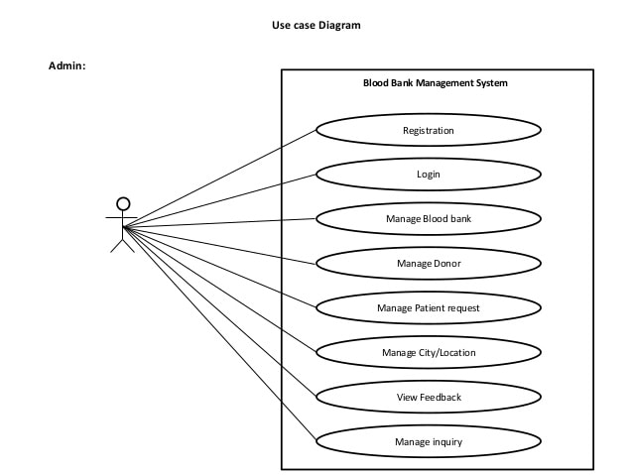

**Table 1. Use Case Diagram for Admin**

1. **Donor**

csdv



**Table 2. Use Case for Donor Model**

1. **Organization**

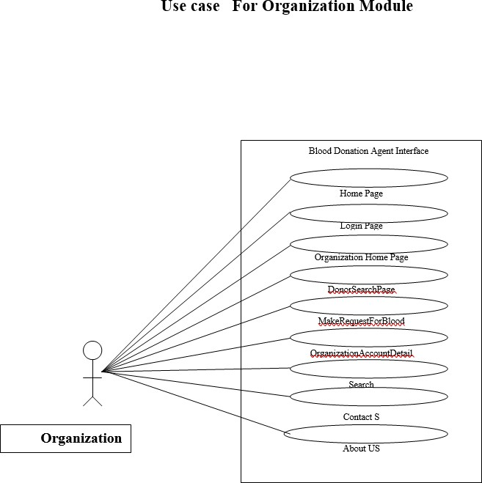

**Table 3. Use Case For Organization Model**

**5.1.2 Sequence Diagram**

**Admin:-**

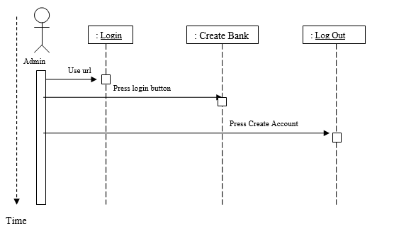

**Donor:**

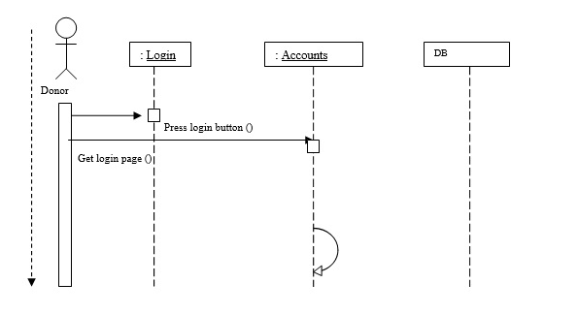

**Organization :**

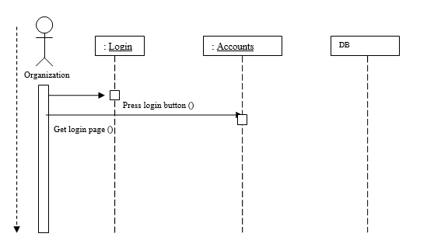

* 1. **Proposed user interface design**

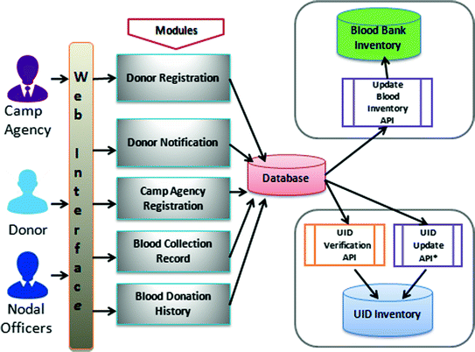

* 1. **Database design changes**

**Entities with Attributes**

1. **BDM_BloodDonationDetails**
   * ID

* Donor I D
* DonationDate
* TakerID
* OrgID
* Quantity
* Comment

1. **BDM_Address**

* AddressID
* AddressLine1
* LocationID
* CityID
* StateID
* CountryID
* Zipcode

1. **BDM_BloodDonationPreference**

* PreferenceID
* UserAccountID
* WantToDonateWhitecells
* Active

4. **Blood Request**

* RequestID
* DonorId
* OrgId
* Name
* Email
* Phone
* Country
* State
* City
* Location
* BloodRequireAddress
* BloodType

1. **BDM_Country**

* CountryID
* CountryName
* CountryDesc
* CountryCode
* Active

6. **Blood Group**

* AppDate
* ReqDate
* Status
* RequestType

1. **BDA_City**

* CityID
* CityName
* CityDesc
* CityCode
* StateID
* Active

1. **BDM_BloodGroup**

* BloodGroupID
* BloodGroup
* Description
* Active

1. **BDM_Blood Type**

* BloodTypeID
* TypeName
* TypeDesc
* Active

1. **BDM_DonationFrequencies**

* FrequencyID
* Frequency
* Description

1. **BDM_UserAccount**

* AccountID
* Username
* Password
* UserDesc
* HintQuestion
* Answer
* RoleID
* Active

1. **BDM_State**

* StateID
* StateName
* StateCode
* StateDesc
* CountryID
* Active

1. **BDM_Organisation**

* OrgID
* OrgName
* OrgType
* Email
* OrgAddrID
* OrgImageURL
* OrgDescription
* ContactNo
* MobileNo
* Active
* Comment

1. **BDM OrganisationType**

* TypeID
* TypeName
* TypeDescription
* OrgImage
* Active

1. **BDM_Employee Detail**

* EmpId
* Name
* Address
* Phone
* Email
* Active

1. **BDM_Location**

* LocationID
* LocationName
* LocationDesc
* LocationCode
* CityID
* Pincode
* Active

1. **BDM_PreferredDonationDayTime**

* DonorPreferenceID
* WeekDay
* TimeFrom
* TimeUpto
* UserAccountID
* Comment
* Active

1. **BDM_DonorPreferredOrganisation**

* UserAcountID
* OrganisationID
* Active

1. **Active BDM_Country**

* CountryID
* CountryName
* CountryDesc
* CountryCode
* Active

1. **BDM PersonalDetails**

* UserAccountID
* FirstName
* MiddleName
* LastName
* Email
* DOB
* Weight
* Gender
* ImageURL
* BloodGroupID
* BloodType
* AddressID
* ContactNo_Office
* ContactNo_Residence
* MobileNo
* Active

1. **BDM_FAQ**

* FaqID
* Question
* Answer
* Active
  1. **Refactoring related changes**
  2. **Construction strategy and re-use**

1. **Details of alternative design approach**
2. **Other technical changes**
   1. Automation tasks/changes
   2. CI/Build relates tasks /changes
   3. Non-functional related changes
3. **Additional details**
   1. Open Questions / clarifications/assumptions
   2. Additional notes to technical team

**REFERENCES;-**

1. Chapman J., unlocking the essentials of effective blood inventory management. Transfusion,2007; 47:190–96S.
2. Managing Blood and Blood Product Inventory – Guidelines for Australian Health Provinces. National Blood Authority, Australia. www.blood.gov.au, April 2013.
3. Shyam Sundaram and T. Santhanam, Classification of Blood Donors using Data Mining,Proceedings of the Semantic E-Business and Enterprise Computing, pp. 145-147, 2009.
4. N.J. Jensen and J.T. Crosson MD, An automated system for bedside verification of the match between patient identification and blood unit identification, March 1996
5. Process of National Blood Transfusion service, Sri Lanka.http://nbts.health.gov.lk/nbts/index.php/donate-blood (accessed Feb 20, 2015).
6. Teena, C.A, Sankar, K. and Kannan, S. ,A Study on Blood Bank Management4, 2014
7. [7] Liyana, F. ,Blood Bank Management System Using Rule-Based Method,2017
8. Dr.Saranajeewa,www.dailymirror.lk/medicine/Donate-blood-and-save-your-fellowCitizens/308-144704.

[9] Kumar, R., Singh, S. and Ragavi, V.A, Blood Bank Management System,2017 [10] Statistics Unit – National Blood Transfusion Service, ANNUAL STATISTICS REPORT,2018.